Group 1

Milestone #3

Jon Green, Taylor King, Austin Moore, Joseph Smith

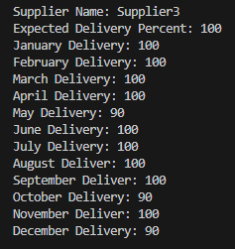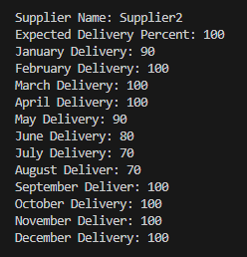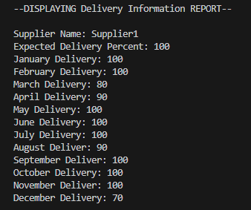**Report 1**: This report shows the suppliers and delivery percentages for each month. This gives Stan and Davis a better idea of how well their suppliers are doing, and if there is any trends or issues from these suppliers. (*deliveries.py*)

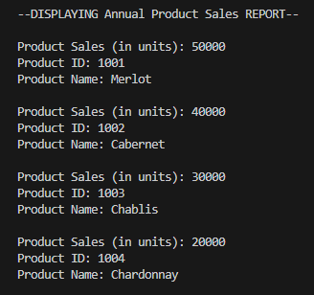**Report 2**: This report shows the annual product sales for each individual product. (*Bacchus4.py*)

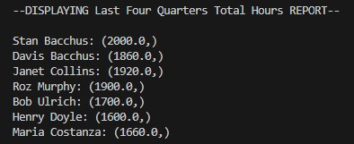**Report 3**: This report shows the employee’s hours for the past 4 quarters. (*Bacchus.py*)